C/C++ RESERVATION SYSTEM LAB REPORT

1) Enter your name, student ID, platform (Mac or PC) and date
Name: Jay Gupta
Class: CIS054 C/C++ Programming
Platform (Mac or PC): PC
Date: 4/25/2020

DESCRIPTION:
Write a program that reserves seats for a theater, airline, etc. using a two-dimensional array. The program should start by asking for the number of rows and seats on each row and display the available seats. The rows are to be identified by a number starting at ‘1’. The seats on each row are to be identified by a letter, ‘A’, ‘B’, ‘C’, etc. For example, 3C, 4A and 2D are sample seat identifiers.

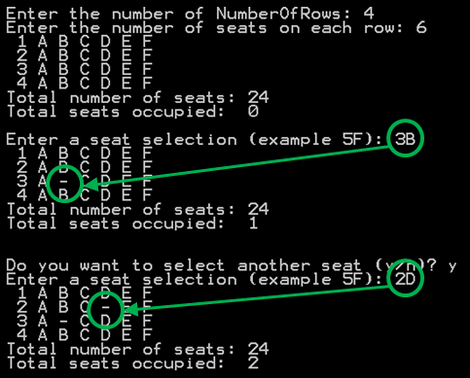
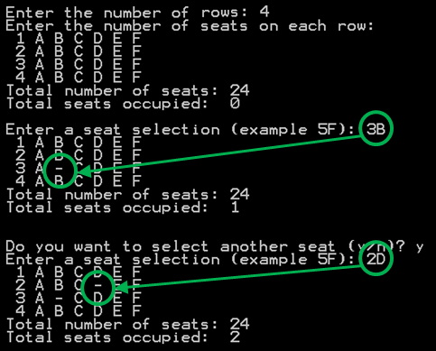
Because the total number of rows and seats is unknown when the program first starts, it will be necessary for the program to dynamically allocate memory for the seating array and then release that memory when the program ends.

The program should ask the user to select row and seat. The program needs to verify and process only legal row and seat requests. If the seat is already reserved, the program should notify the user that the seat is taken. If the seat is available, the program should replace the seat identifier with a dash character ‘-‘. The program should contain a loop to ask if additional seats are to be reserved. The program should also give a message when all the seats are taken. A counter must be used to keep track of and display the total number of seats purchased.

When running the program, you must use a minimum of 3 rows and 4 seats. The lab report must show these minimums. The program output must also show:
a) a sample display of when more than one seat is taken, and
b) another display showing a message when all seats are taken. You can use 2 rows by 2 seats for this.

LAB REPORT:
2) Fill in the HIPO chart using English or pseudo-code. Do NOT paste your program or any part of it in the PROCESSING section.
INPUTS | PROCESSING | OUTPUTS
- Number of rows & columns  - Seat Selection(s) (there can be 1 or multiple) | - Get input from user regarding number of seats and rows (+input validation).  - Calculate total number of seats, display all available seats.  - Get seat selection from user (+input validation).  - Display new seat view and number of occupied seats.  - If user quits or all seats are occupied, display appropriate message.  - Memory cleanup to free memory. | - Display of available seats  - Total number of seats  - Occupied seats
DISCUSSION:
3) Complete the DISCUSSION section. It does not need to be long, but it needs to be complete.
3a) What did you do to develop the program? ("Followed the Directions" is not a complete description)

To develop the program, I looked at your video on pointers and arrays. I didn’t understand on the first view, and, as you instructed in your video, I viewed the video another time. I understood a lot more, and worked on the project. I viewed the code, and created the main functions.

I tried understanding as much as I could; at certain parts, I’m not afraid to admit, I ‘crammed’ as the definition seemed to advanced for my current level of understanding. However, for the most part, I understood to the point where I could probably program most of the project on my own.

I unit tested certain parts of the program using an online code editor.

3b) What problems did you have and how did you overcome the problems?

I had a few problems with converting the rows and columns to their appropriate ‘programming’ equivalent. I at first tried to use a string, and then split it into an integer and character. However, I found
it easier to cin >> them individually.

Overall, conceptually understanding the topic was the hardest problem for me, and to remedy this problem, I viewed your video as well as others on YouTube. Pointers and referencing seem like a big topic in programming; I’m planning to go deeper into the subject even after this project.

PROGRAM OUTPUT:
4) Show a screen shot for purchases of at least TWO seats and another screen shot with a message that shows what happens when ALL seats have been purchased.
Refer to previous lab assignments for instructions on how to capture a screen or portions of a screen for either the PC or a Mac

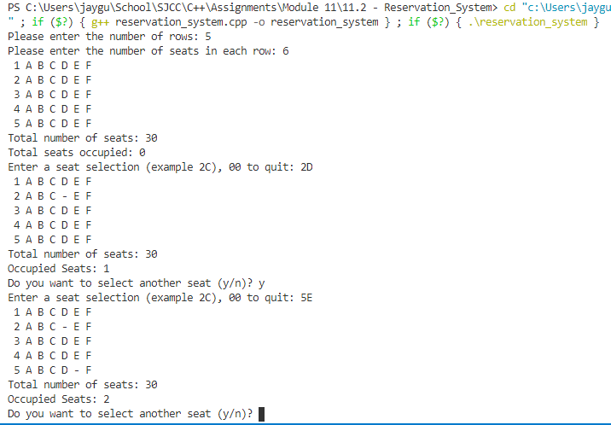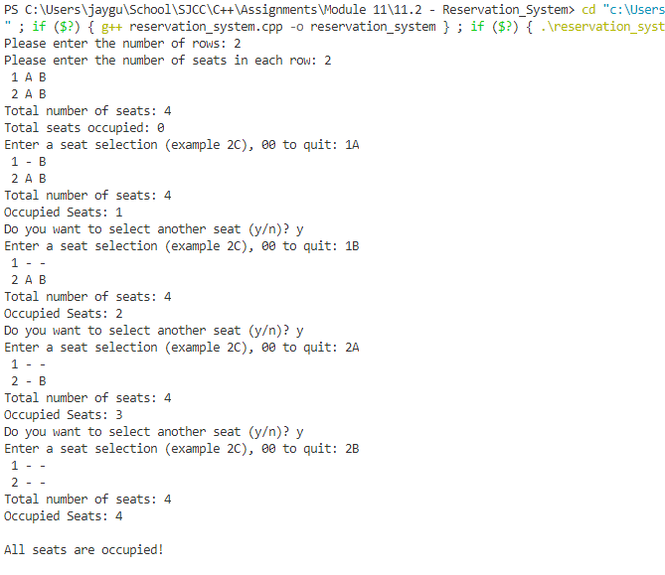

PROGRAM LISTING:
5) Copy and paste the code for your program. Your program should include a comment block at the top that shows the name of the program, date, version and your name.

/**
* Name: Jay Gupta
* Date: 4/25/2020
* Class: CIS 054 C/C++ Programming
* File Name: reservation_system.cpp (V1.0)
* Code Editor: VS Code
* Platform: PC
*/

#include <iostream>
#include <string>
using namespace std;

// function declarations
char **createArrayOfSeats(int rowQuantity, int seatQuantity);
void initializeSeats(char **arrayOfSeats, int rowQuantity, int seatQuantity);
void displayArrayOfSeats(char **arrayOfSeats, int rowQuantity, int seatQuantity);
void memoryCleanup(char **arrayOfSeats, int rowQuantity, int seatQuantity);

// ** before arrayOfSeats is used to say "address of"

int main() {
// variable declarations
char **arrayOfSeats; // pointer to dimensional array
int numberOfRows, numberOfSeats, totalNumberOfSeats, occupiedSeats;
char answer; // Do you want another seat (y/n)?
char userRow;
char userColumn;
bool isValid = false;

// get array dimensions
// get array dimensions
cout << "Please enter the number of rows: ";
cin >> numberOfRows;
while (cin.fail() || numberOfRows <= 0) {
cout << "ERROR: A number greater than 0 must be entered: ";
cin.clear();
cin.ignore(123, '\n');
cin >> numberOfRows;
}

cout << "Please enter the number of seats in each row: ";
cin >> numberOfSeats;
while (cin.fail() || numberOfSeats <= 0) {
cout << "ERROR: A number greater than 0 must be entered: ";
cin.clear();
cin.ignore(123, '\n');
cin >> numberOfSeats;
}

// calculate total number of seats, set occupiedSeats to 0
totalNumberOfSeats = numberOfRows * numberOfSeats;
occupiedSeats = 0;

// display initial arrayOfSeats, and total number of seats + occupied
arrayOfSeats = createArrayOfSeats(numberOfRows, numberOfSeats);
initializeSeats(arrayOfSeats, numberOfRows, numberOfSeats);
displayArrayOfSeats(arrayOfSeats, numberOfRows, numberOfSeats);
cout << "Total number of seats: " << totalNumberOfSeats << endl;
cout << "Total seats occupied: " << occupiedSeats << endl;

// get seat requests
do {
// get seat selection from the user
do {
cout << "Enter a seat selection (example 2C), 00 to quit: ";
cin >> userRow;
cin >> userColumn;
if (userRow == '0' && userColumn == '0') {
break;
}
userRow = userRow - '1';
userColumn = toupper(userColumn) - 'A';
if (userRow < 0 || userRow >= numberOfRows || userColumn >= numberOfSeats) {
isValid = false;
} else {
if (arrayOfSeats[userRow][userColumn] == '-') {
cout << "The requested seat is already taken." << endl;
continue;
} else {
arrayOfSeats[userRow][userColumn] = '-';
occupiedSeats++;
displayArrayOfSeats(arrayOfSeats, numberOfRows, numberOfSeats);
cout << "Total number of seats: " << totalNumberOfSeats << endl;
cout << "Occupied Seats: " << occupiedSeats << endl;
isValid = true;
}
}
} while (!isValid);

if (userRow == '0' && userColumn == '0') {
break;
}

// check if all seats are occupied
if (totalNumberOfSeats == occupiedSeats) {
cout << endl << "All seats are occupied!" << endl << endl;
break;
}

// ask user if they want another seat
cout << "Do you want to select another seat (y/n)? ";
cin >> answer;
answer = toupper(answer);
} while (answer == 'Y');

memoryCleanup(arrayOfSeats, numberOfRows, numberOfSeats);
return 0;
}

char **createArrayOfSeats(int rowQuantity, int seatQuantity) {
/*
dynamically creating double-dimensional array requires an array of
pointers, with each pointer being an array of characters
*/

char **arrayOfSeats; // declare dimensional array
// initializing the array to be a certain number of rows
arrayOfSeats = new char*[rowQuantity]; // each row contains an array of pointers
for (int r = 0; r < rowQuantity; r++) {
arrayOfSeats[r] = new char[seatQuantity]; // each row is an array of characters
}
return arrayOfSeats;
}

void initializeSeats(char **arrayOfSeats, int rowQuantity, int seatQuantity) {
// first for loop: a specific row
for (int r = 0; r < rowQuantity; r++) {
for (int s = 0; s < seatQuantity; s++) {
// the '+ s' allows the A to change to B, C, D, etc.
arrayOfSeats[r][s] = 'A' + s;
}
}
}

void displayArrayOfSeats(char **arrayOfSeats, int rowQuantity, int seatQuantity) {
// for each row
for (int r = 0; r < rowQuantity; r++) {
cout.width(2); // adds two empty spaces before anything is shown
cout << r + 1 << ' '; // display row numbers starting from 1, followed by a space
for (int s = 0; s < seatQuantity; s++) {
cout << arrayOfSeats[r][s] << ' '; // display A, B, C, etc. for each seat, and space
}
cout << endl; // new line after every row
}
}

void memoryCleanup(char **arrayOfSeats, int rowQuantity, int seatQuantity) {
// delete each row individually
// each row contains a character array
for (int r = 0; r < rowQuantity; r++) {
delete [] arrayOfSeats[r];
}
// arrayOfSeats is now just an array of pointers
delete [] arrayOfSeats; // delete it
}

